**Objective**: Install Raspberry Pi operating system—Raspbian OS with NOOBS.

**Parts:**

* RPi 3 B
* Any computer with a USB port
* Micro-SD card(at least above 8GB in size)
* Micro-SD card reader

**Part A:** There are several ways to install Raspbian OS on RPi. Today, we will be using NOOBS.

**Step 1.** Put Micro-SD card into your Micro-SD card reader and plug the reader into an USB adapter, then insert it onto the USB port on your computer.

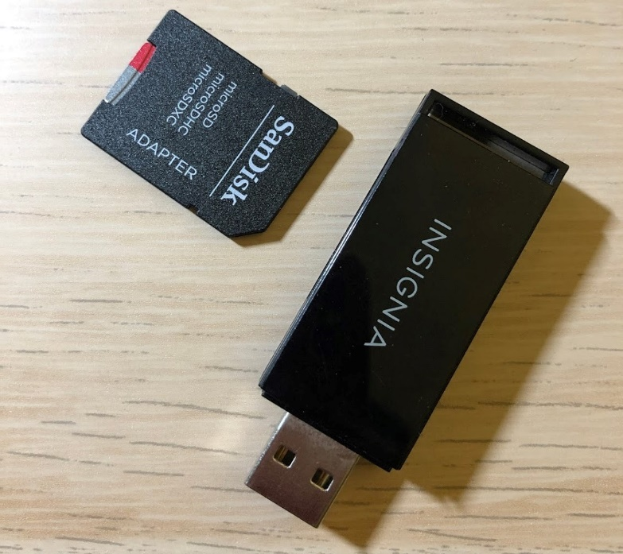

**Step 2.** Visit <https://www.raspberrypi.org/downloads/>. You should see a box with a link to the NOOBS files. Click on the icon to go to that link.

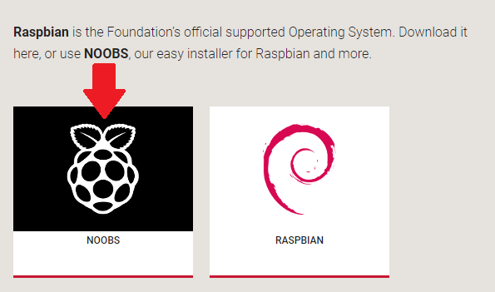

**Step 3.** The simplest option is to download the zip archive of the files.

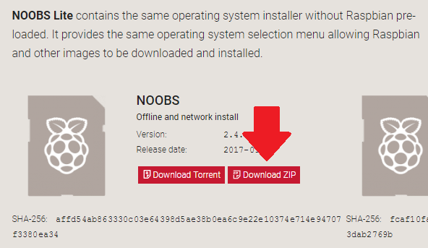

**Step 4.** Format the Micro-SD card. It’s a good practice to always format your card before trying to install an OS on it because you will never know whether there is any leftover files on it. There is a default tool in Windows to format the SD card, but since some students might use a Mac, we will use a universal tool. Visit the SD Association’s website(<https://www.sdcard.org/downloads/formatter_4/index.html>) and download the latest version of SD Formatter for Windows or Mac. Follow the instructions to install the software.

**Step 5.** In SD Formatter, select the driver letter for your SD card, and format it.

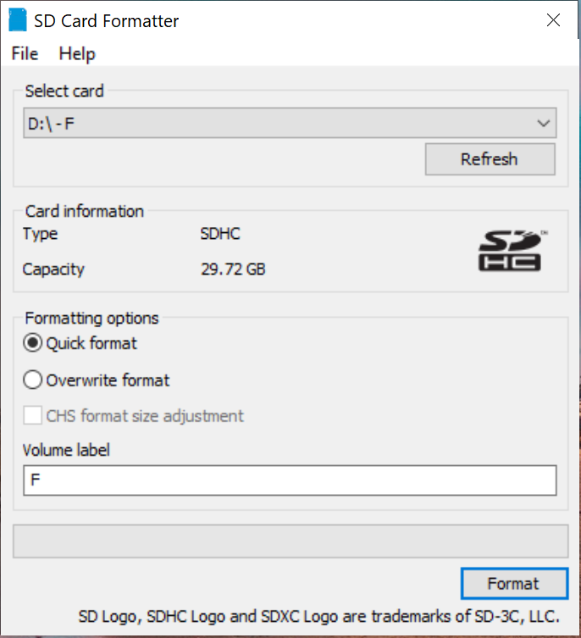

**Step 6.** Next, find the NOOBS zip archive you just downloaded from the RPi website. Extract the files and keep the resulting Explorer/Finder window open.

**Step 7.** Now, open another Explorer/Finder window and navigate to the SD card. Select all the files from the NOOBS folder and drag them onto the SD card.

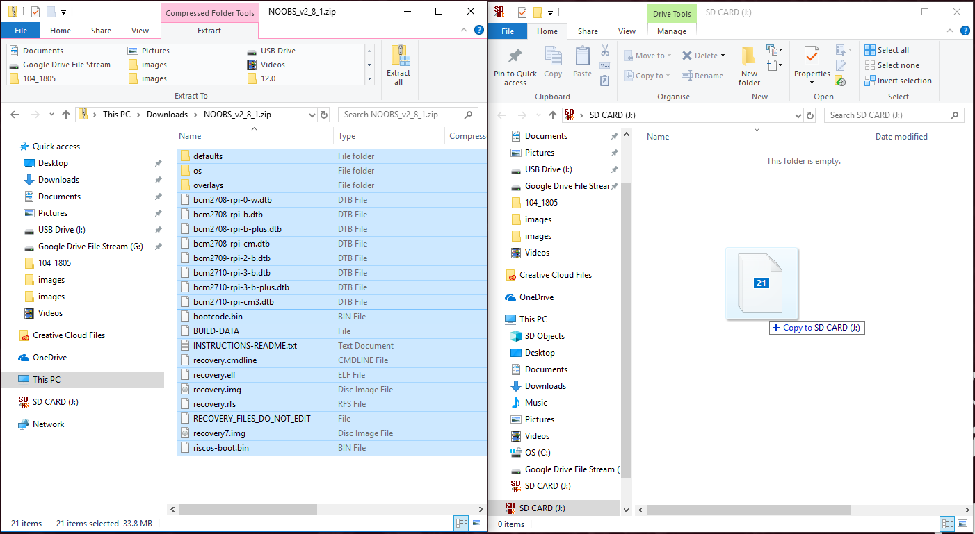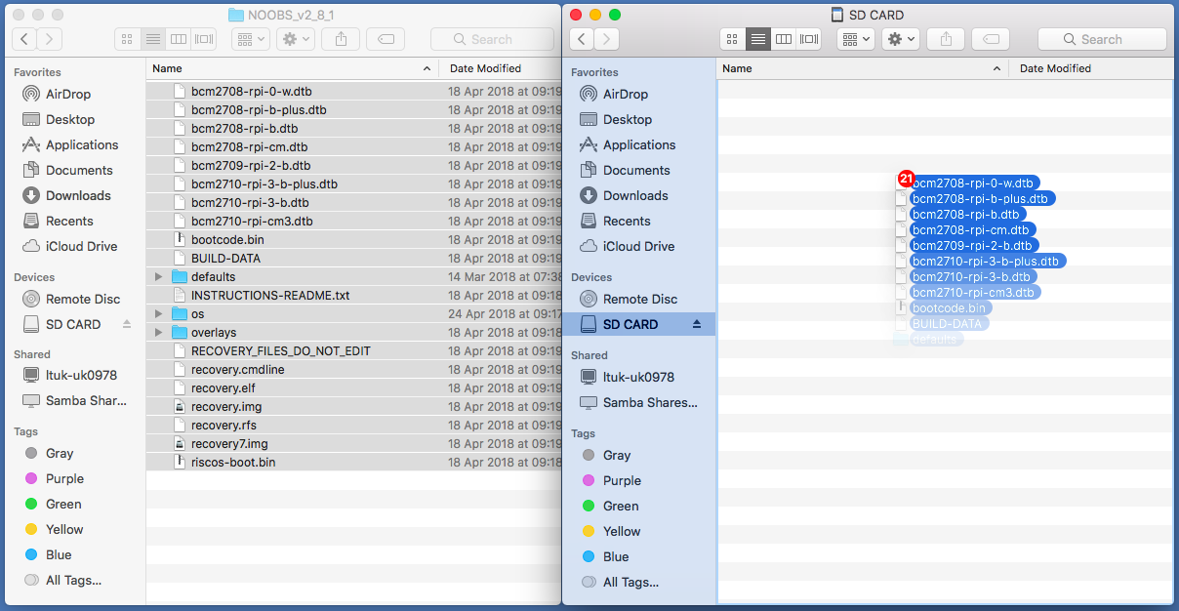

**Step 8.** Eject the SD card from your computer. Insert the micro-SD card into your RPi and plug the Pi into a power source. Your RPi should be booting up right after you plug into a power source.

**Step 9.** A window will prompt when the installer has loaded automatically. Check the box for **Raspbian** and then click **Install** on the top left hand side of the window.

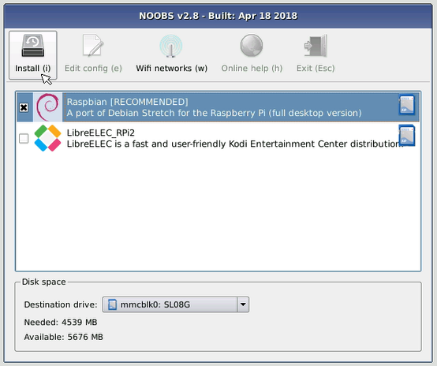

**Step 10.** Click **Yes** at the warning dialog, and then sit back and relax. It will take a while depends on what kind of SD card you have.

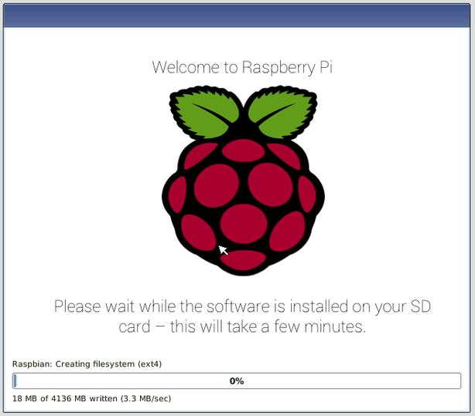

**Step 11.** When Raspbian has been installed, click **OK** and your RPi will restart and Raspbian OS will boot up. Congratulation! You just install Raspbian OS on your RPi.

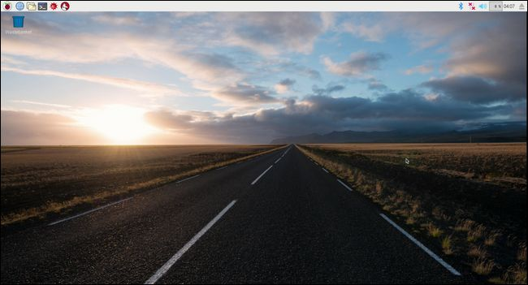

**Step 12.** Finish the follow-up tutorial in the “Getting Started with the RPi.docx”.